MPX Users Manual

V 0.2

Perpetual Motion Squad

10/7/2010

When you initially boot up PMOS it will give you a startup message and then bring you to a command prompt. From this command prompt you can choose from several types of functions supported by PMOS. The following is a list of functions supported by PMOS and a description of how to use them.

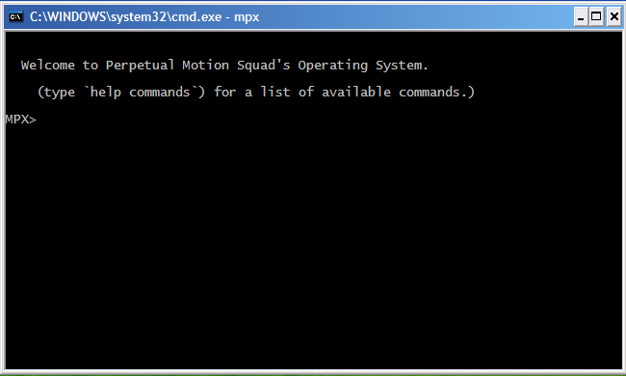

Unblocked-This function is used by typing "unblock name". Where name is the process you would like unblocked.

Suspend- This function is used by typing "suspend name". Where name is the process you want to suspend.

Show Ready- This function is used by typing "showReady". This function shows detailed information about all process in the ready and suspended-ready states.

Show Blocked- This function is used by typing "showBlocked". This function shows detailed information about all processes currently in the ready and suspended-ready state.

Show All- This function is used by typing "showAll". It shows detailed information about all current processes.

Show- show is used by typing "show name". Where name is the name of the process you are trying to view information about.

Set Priority- This function is used by typing "setPriority name priority". Where name is the process you want to set and priority is from -128 to 127.

Resume- This function is used by typing "resume name". Where name is the process you want to resume.

Load- This function is used by typing "load path". Where path is the directory to search for PMOS files.

Help- This function is used by typing "help command". It displays information about the current process supported by PMOS. If command is left blank or information about the command you use as your argument

Exit- This command is used by typing "exit". It exits the PMOS after a user prompt.

Delete- This function is used by typing "delete name". Where name is the name of the process for deletion.

Date- This function is used by typing "date". It shows detailed information about the current system date.

Create- This function is used by typing "create name type priority". Where name is the name of the process, type is 0 for application 1 for system, and priority is a value from -128 to 127.

Block- This function is used by typing "block name". Where name is the -process you want blocked.

Version- This command is used by typing "version". It shows detailed information about the current version of PMOS.